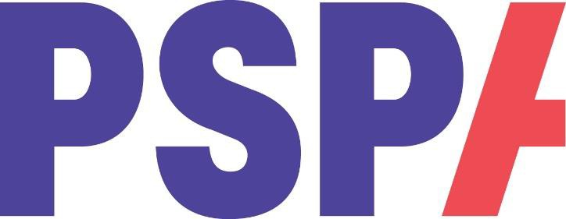

**Volunteer Complaints Procedure**

PSPA aims to create a work environment where volunteers feel valued whilst volunteering. However, we recognise there may be occasions where volunteers have concerns and complaints. This procedure enables individual volunteers to raise concerns and complaints more formally. The procedure provides an open and fair way for volunteers to make known their problems and, we hope, will lead to a speedy resolution.

**STAGE ONE – INFORMAL DISCUSSION**

If you have a grievance or complaint about your volunteering role, you should discuss it informally with the Director of Service Improvement & Development. We hope that the majority of concerns will be resolved at this stage.

**STAGE TWO – COMPLAINT**

If the matter is not resolved through informal discussions, you may raise the matter, in writing. We will need to know, in writing, the following:

* Exactly what the problem is and how it occurred.
* How it has affected you.
* What you consider should be done to put the matter right.

You will need to give as much information as possible.

All complaints should be marked Private & Confidential and addressed to The Director of Service Improvement & Development, PSPA, Margaret Powell House, 415a Midsummer Boulevard, Milton Keynes, MK3 9BN.

We will acknowledge your complaint within seven working days of receipt, provide you with the name, and contact details of the person responsible for investigating the matter on your behalf.

**STAGE THREE – INVESTIGATION**

The person responsible for the investigation will write to you with their findings and resolution as soon as possible. If you wish, you may attend a meeting to discuss the findings and resolution. At the meeting, you may be accompanied by a friend or fellow volunteer.

**STAGE FOUR – APPEAL**

If the matter is not resolved to your satisfaction, you may seek an appeal with the Chief Executive. Letters of appeal must be received within 10 working days from the date on the letter notifying you of the outcome of the investigation.

You will be entitled to have a meeting with the Chief Executive to discuss the matter. A friend or fellow volunteer may accompany you. The Chief Executive will give his/her final decision within seven working days. The decision will be final.

**ANNOYMOUS COMPLAINTS**

If you wish to make a complaint anonymously, then we will treat this as a comment, as we will be unable to advise you of the outcome of the investigation.

April 2024

Review date: May 2025