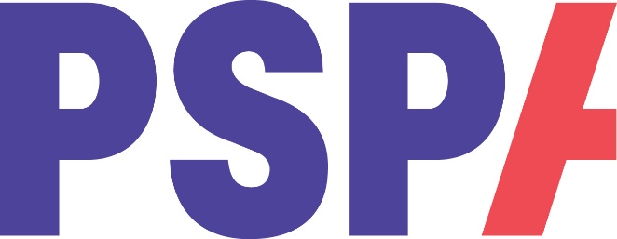

PSP & CBD Training Event

(insert name) PSPA Education Volunteer will be sharing his/her knowledge of Progressive Supranuclear Palsy (PSP) & Corticobasal Degeneration (CBD)

If you would like to know more about these neurodegenerative conditions, please join us on:

**Insert date and time**

[**www.pspassocation.org.uk**](http://www.pspassocation.org.uk)