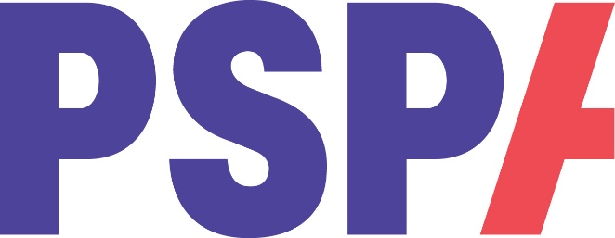
PSP & CBD Training Event

(insert name) PSPA Education Volunteer will be sharing his knowledge of Progressive Supranuclear Palsy (PSP) and Corticobasal Degeneration (CBD)

If you would like to know more about these neurodegenerative conditions, please join us on:

Monday, 14 October 2019
at 2pm

www.pspassocation.org.uk

